F260
Hanes
Ultimate Cotton
Crewneck Sweatshirt

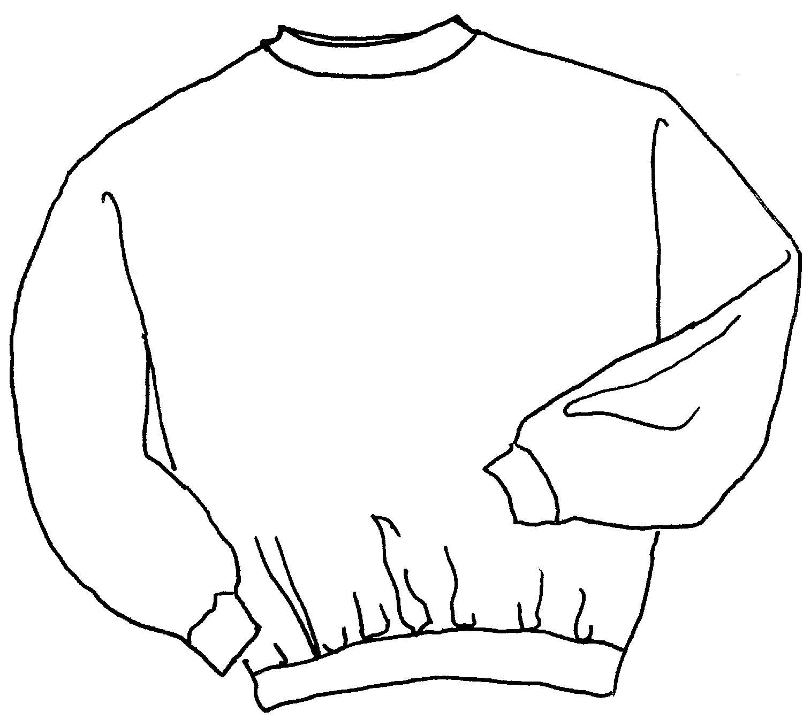

Descriptions
*90/10 cotton poly, 10.1 ounce Printpro fleece
*Fully coverseamed
*Spandex in collar, cuffs & waistband
*Set in sleeves
*Embroidery or screenprinting okay

Finished Garment Measurements

Size | S | M | L | XL | 2XL | 3XL
Width | 21 | 23 | 25 | 27 | 29 | 31
Length | 28 | 29 | 30 | 31 | 32 | 33
Sleeve length from CB | 35 | 35 | 36 | 37 | 37 ½ | 38

